APPLECROSS SENIOR HIGH SCHOOL

YEAR 11 HUMAN BIOLOGY

Genetics Assessment

Name:_____________________ Mark: /20

Complete your answers in pen. You will lose 1 mark if answers are in pencil.

1. The pedigree below shows the inheritance of a genetic disease called amaurotic idiocy. It is an autosomal trait. This disease causes degeneration of the brain and affected individuals die during childhood. Affected individuals in this family are indicated by shading.

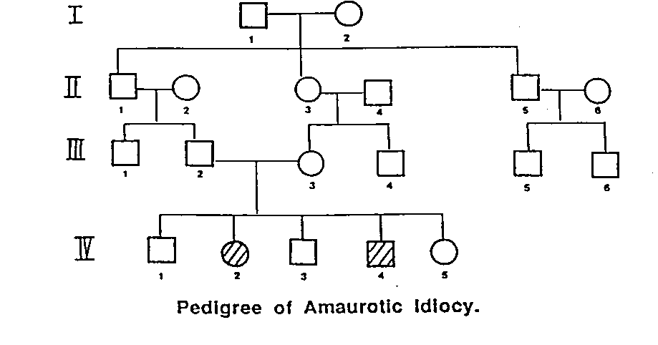

Based on the pedigree, answer the following questions.

(i) Is this disease dominant or recessive? _____________________________ [1 mark]

Explain your answer:

_______________________________________________________________________
_______________________________________________________________________
_______________________________________________________________________ _______________________________________________________________________
[2 marks]

(ii) What is the genotype of individual III 2 ?__________________________ [1 mark]

Define the symbols that you use:

[1 mark]

(iii) What is the possible genotype of individual IV 1? _____________________________ [1 mark]
Explain the reasoning behind your answer.
_____________________________________________________________________
_____________________________________________________________________
_____________________________________________________________________
_____________________________________________________________________ [1 mark]

(iv) If individual IV 5 is heterozygous for the trait and she marries a normal male with no family history of amaurotic idiocy, what is the probability that their first child will be born with amaurotic idiocy?

Set out the cross in full: [4 marks]

Probability of first child with amaurotic idiocy = _____________
[2 marks]

2. Red-green colour blindness is a recessive, X-linked trait. A man who is not red-green colour blind marries a woman who is also not red-green colour blind, but her father was red-green colour blind. They have a son and a daughter. Provide a key and set out this cross in full: [4 marks]

Working:

(i) What is the probability that the son will be red-green colour blind?

____________________________________________________________________ [1 mark]

(ii) What is the probability that the daughter will be red-green colour blind?

____________________________________________________________________ [1 mark]

(iii) What is the probability that the daughter will be a carrier of the red-green colour blindness gene?

____________________________________________________________________ [1 mark]

